

## [**Recruitment**](http://en.wikipedia.org/wiki/Recruitment) **System**

## **For**

## [**Inova IT Systems (Pvt) Ltd.**](http://www.inovaitsys.com/)

Project Proposal

Information Technology final project

Project ID: HDCS 2013/14FT-NU-04

Submitted by:

Submitted to:

…………………………..

Mr.

15/09/ 2014

# Abstract

This project is for a data analysis and recruitment system. we make this project for the Inova it systems [pvt] ltd. it is a software development company focusing on bespoke software development, software product development, enterprise application integration, human resource outsourcing and it consultancy services for a number of industries including e-commerce, banking and finance, telecommunication etc.

This cased them faced lots of problems, CV handling, CV sorting and CV missing no records about past candidate. Also they waste lots of time to select employee.

So we met their General Manager Terrence Priyanath Medawatta and suggested with us and gave their requirement about his system we are working together to complete our mission and we are sure that we can fully process of the recruitment system of the Inova IT Systems (Pvt) Ltd.

So our team got their requirements and planned to do our first project well. We mainly targeted to satisfied our client and make which is actually client wanted.

# Contents

1. Introduction and Description of the Project ……………………………………………………….3
   1. Problem Specification………………………………………………………………………...3
   2. Solution Outline………………………………………………………………………………4

1.2.1 Collect curricula vitae…………………………………………………………………....5

1.2.2 Employee privileges……………………………………………………………………..5

1.2.3 Security………………………………………………………………………………......6

* + 1. Criteria checking system ………………………………………………………………..7
    2. Interview data handling system………………………………………………………….7
    3. Candidate changing system……………………………………………………………...9
    4. Time wastage ……………………………………………………………………………10
  1. Key benefits…………………………………………………………………………………….10

2. Objectives………………………………………………………………………………………….11

2.1 Login System ………………………………………………………………………………....11

2.2 Candidate System …………… ………………………………………………………………..11

2.3 Criteria checking System ……………………………………………………………………..12

2.4 Interview Data Handling System….………………………………………………………….12

2.5 Candidate Changing System….………………………………………………………………..12

3. Procedures....................................................................................................................................13

3.1 Flow of the Project…………………………………………………………………………...13

3.1.1 Feasibility Study………………………………………………………………….…...13

3.1.2 Requirement Analysis…………………………………………………………………13

3.1.3 System Analysis……………………………………………………………………….14

3.1.4 System Design…………………………………………………………………………14

3.1.5 Implementation and Unit Testing……………………………………………………...15

3.2 Project Plan……………………………………………………………………………...........16

4. Personnel and Facilities……………………………………………………………………......17

5. Hardware and Software Requirements………………………………………………………….18

5.1 Hardware Requirements ………………………………………………………………18

5.2 Basic System Requirements…………………………………………………………..18

5.3 Software Requirements………………………………………………………………..18

6. Budget …………………………………………………………………………………………19

7. Reference……………………………………………………………………………………….20

1. **Introduction and Description of the Project**

Our goal is to develop a recruitment system for Inova IT Systems (Pvt) Ltd. Within these five weeks. According to our observation reports, we have found several significant functions.

This system is specifically going to be developed to recruitment system the above mentioned processes. In this processes, Candidate fills and sends the curriculum vitae. System is filtering the client criteria and Check the selected curriculum vitae through the system with HR Manager. After sending the email through the system to the selected applicant and present data in web site. Give selected candidate data other companies.

* 1. **Problem Specification**

Our main purpose is to do their work easily gain more curriculum vitae by recruitment their system that allows lots of benefits to Inova IT Systems (Pvt) Ltd. we give solutions for their problems mentioned here.

1. There are lots of problems happened while collecting the curriculum vitae.

2. When they are filter the curriculum vitae as they requirements since when they has to manually selecting curriculum vitae

3. They have to spend some more time to filtering the curriculum vitae under the steps of interviews.

As a result of this lot of time is been wasted .the requirement of the client is to get the curriculum vitae which includes the wanted requirement of the client, out of all the curriculum vitae that the client was received

* 1. **Solution Outline**

In order to overcome these problems we decided to implement a web based recruitment system.

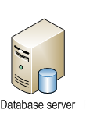

**Recruitment System**

Database server





Web server

Internet

Web server

Candidate



Email server

Official

Users

Email server



Normal employers

System administrator

HR manager

Figure 1.2: Recruitment System

* + 1. **Collect curricula vitae**

Candidate enters to the web page and candidate can fills forms and register. It will be stored in database candidate will be assigned to an access level which he could use to log in to the system.

1. Fill curricula vitae.
2. View the selected or unselected.





Web server

Candidate

Web browser





Web browser

Email server

Figure 1.2.1: Collect curricula vitae

**1.2.2 Employee Privileges**

System administrator can insert a new employee the details of the employees will be entered and will be stored in the database and employee will be assigned to an access level which he could use to log into the system.

1. Give access privileges.( normal employees and HR manager)
2. Store data in database.



Web server

Database server

Administrator

Web browser

Figure 1.2.2: Employee privileges

* + 1. **Security**

Each and every employee has a logging, so system can recognize their user levels and it gave the access permission according to user levels.

1. Input user name and password.
2. Validated & suitable option according to the validation.



Database server

Web server

Web browser

Employee



Web browser

Figure 1.2.3.Employee security

Each and every candidate has a logging, so system can recognize their user levels and it gave the access permission according to user levels and view selected or unselected.

1. Input user name and password.
2. Validated & suitable option according to the validation.



Web browser

Web server

Candidate

Database server



Figure: 1.2.3.Candidate security

Web browser

* + 1. **Criteria Checking System**

System administrator can select CV using the criteria and store selected CV in database. System will be view selected or unselected by candidate. System deletes unselected CV.

1. Select CV using the criteria.
2. View selected or unselected.





Database server

Employee

Web server

Web browser



Candidate

Web browser

Figure: 1.2.4. Criteria checking system

* + 1. **Interview data handling system**

HR manager view first selected cv. HR manager manually filters CV and selected CV. After HR manager sends the mail through the internet and call selected candidate for interviews. Employees insert interviews data.

1. View first selected CV.
2. Send email to selected candidate and call selected candidate for interviews.
3. Employees insert interviews data.



HR manager

Database server

Web server

Web browser



Web browser

Email server

Web browser





Normal employee

Normal employee

Candidate

Figure: 1.2.5. Interview data handling system

* + 1. **Candidate Changing System**

After the final interview, if some companies need qualified candidates Inova Company will send them to selected candidate. Normal employee will insert above candidate data. HRM can search above candidate data.

1. Other companies contact Inova Company. After Inova company will send selected candidate details through the email.
2. Normal employee will store data above candidate.



Other Companies

Contact

HR manager







Web browser

Web browser



Web server



Database server

Email server



Web browser

Normal Employee

Figure: 1.2.5. Candidate changing system

**1.2.7 Time wastage**

As management does not use any automation system currently (work manually), they need more time to spend on CV collection, criteria checking. This system helps them to do their work more efficiently without any time wastage.

* 1. **Key benefits**
     1. **Less time wastage**

Through automating this process we can save management time as well as the time that the CV easily filter using the criteria and candidate can easily fill the cv and submit it without any time wastage .

* + 1. **Security**

Some employees may involve in treachery for their personal benefits by access levels. To prevent this situation we are introducing security levels (employee level, managerial level, administrative level and candidate level) where the access levels cannot be changed or cheated since the information on each item is recorded and that can only be changed by the administrator of the system.

* + 1. **Easy handling**

We are going to introduce a more user friendly system which may help the user save time and feel comfortable to work which may help to increase efficiency.

* + 1. **Record Maintaining**

The proposed database for our system can record each and every detail of login system, criteria checking system, interview data handling system, candidate changing system as long as the user wants and this helps when selecting CV.

1. **Objectives**

Our objectives are to develop a recruitment system to the managers to reduce their workload and a way for candidate to communicate with the management. Our main functions for the system are listed below.

**2.1 Login System**

When the candidate wants to send the CV first register in system after candidate can login to the system. Register details will be stored in the database and candidate will be assigned to an access level which he could use to log into the system.

When the company wants to combine new employees to the system. The details of the employees will be entered and will be stored in the database and employee will be assigned to an access level which he could use to log into the system.

The login system consists of from design, form validation, creating the data base, user management system.

**2.2 Candidate System**

When the company recruits new candidate the company will publish the advertisement. The details of the CV candidate will enter and will be stored in the database. The employees will be able to view their profiles and the administrators or normal employee will be able to change and update candidate details through this system. Also system will allow the managers to produce a report when needed.

The candidate system consists of from design, form validation, creating the data base.

**2.3 Criteria Checking System**

System administrator can select CV using the criteria expected salary, notice period, number of years’ experience and store selected CV in database. System will be view selected or unselected by candidate. System deletes unselected CV 2 week. System generate working report if administrator select CV using the criteria

The Criteria Checking System consists of from design, form validation, creating the data base.

* 1. **Interview Data Handling System**

HR manager view first selected cv. HR manager manually filters CV and selected CV. After HR manager sends the mail through the internet selected candidate for interviews. Employees insert interviews data.

The Interview Data Handling System consists of validation, creating the data base, generate the pdf file.

* 1. **Candidate Changing System**

After the final interview, if some companies need qualified candidates Inova Company will send them to selected candidate. Normal employee will insert above candidate data. HRM can search above candidate data.

The Interview Data Handling System consists of validation, creating the data base, generate report.

**3. Procedures**

**3.1 Flow of the Project**

Through a contact, the project team was able to make an appointment to discuss with the Director at Inova IT Systems (Pvt) Ltd and as there he explain the employees of the company has a problem with their CV data handling processes as they do not have any automated system which is specific to the company.

So our team got their requirements and planned to do our first project well. We mainly targeted to satisfied our client and make which is actually client wanted.

**3.1.1 Feasibility Study**

After gathering information from employees, our group members had some discussion sessions to analyze the information we have gathered and discuss about the feasibility.

• Schedule Feasibility

• Economic Feasibility

• Technical Feasibility

**3.1.2 Requirement Analysis**

As the employees described the company do not have any specific system for gathering CV. There wasn’t a proper recruitment system so the team has to study the manual business process to identify the requirements. The team has decided to get more information from the employees in the company.

**3.1.3 System Analysis**

As the company do not have any remaining system it was totally new task to decide a appropriate system as the requirement analysis have done by studying the manual process. The basic system has been analyzed and there can be differences according to the client requests in the future.

Our next task will be developing the prototype, writing the SRS document and then creating DFD and finally composing the ER diagram.

**3.1.4 System Design**

The design part is decided to do by dividing it into main two parts.

* + - * **Web interface designing**

This will be one of the most important parts in designing because the user is interacting with the interface which is provided. So the interface must be user friendly and must fulfill all the needs of the user.

* **Database Designing**

Database is to be well design as there is lot of information which candidate involved with. So the database is going to be implemented using Logical database design and Scheme refinement by applying Normalization.

**3.1.5 Implementation and Unit Testing**

Then we’ll be distributing functions among group members to implement those functions. After the basic functions are implemented, basically a prototype is to be generated to get feedback from the users of the recruitment system. After the feedback is taken, the necessary changes are to be done.

Next step is to combine the functions together that are implemented by each individual group member and implement the full function for further unit testing.

After implementing the fully functional system, we are planning to do white box testing, black box testing and also the most important part; stress testing is going to be concluded.

Finally our group members suggested implementing the System for selected employees for further testing.

**3.2 Project Plan**

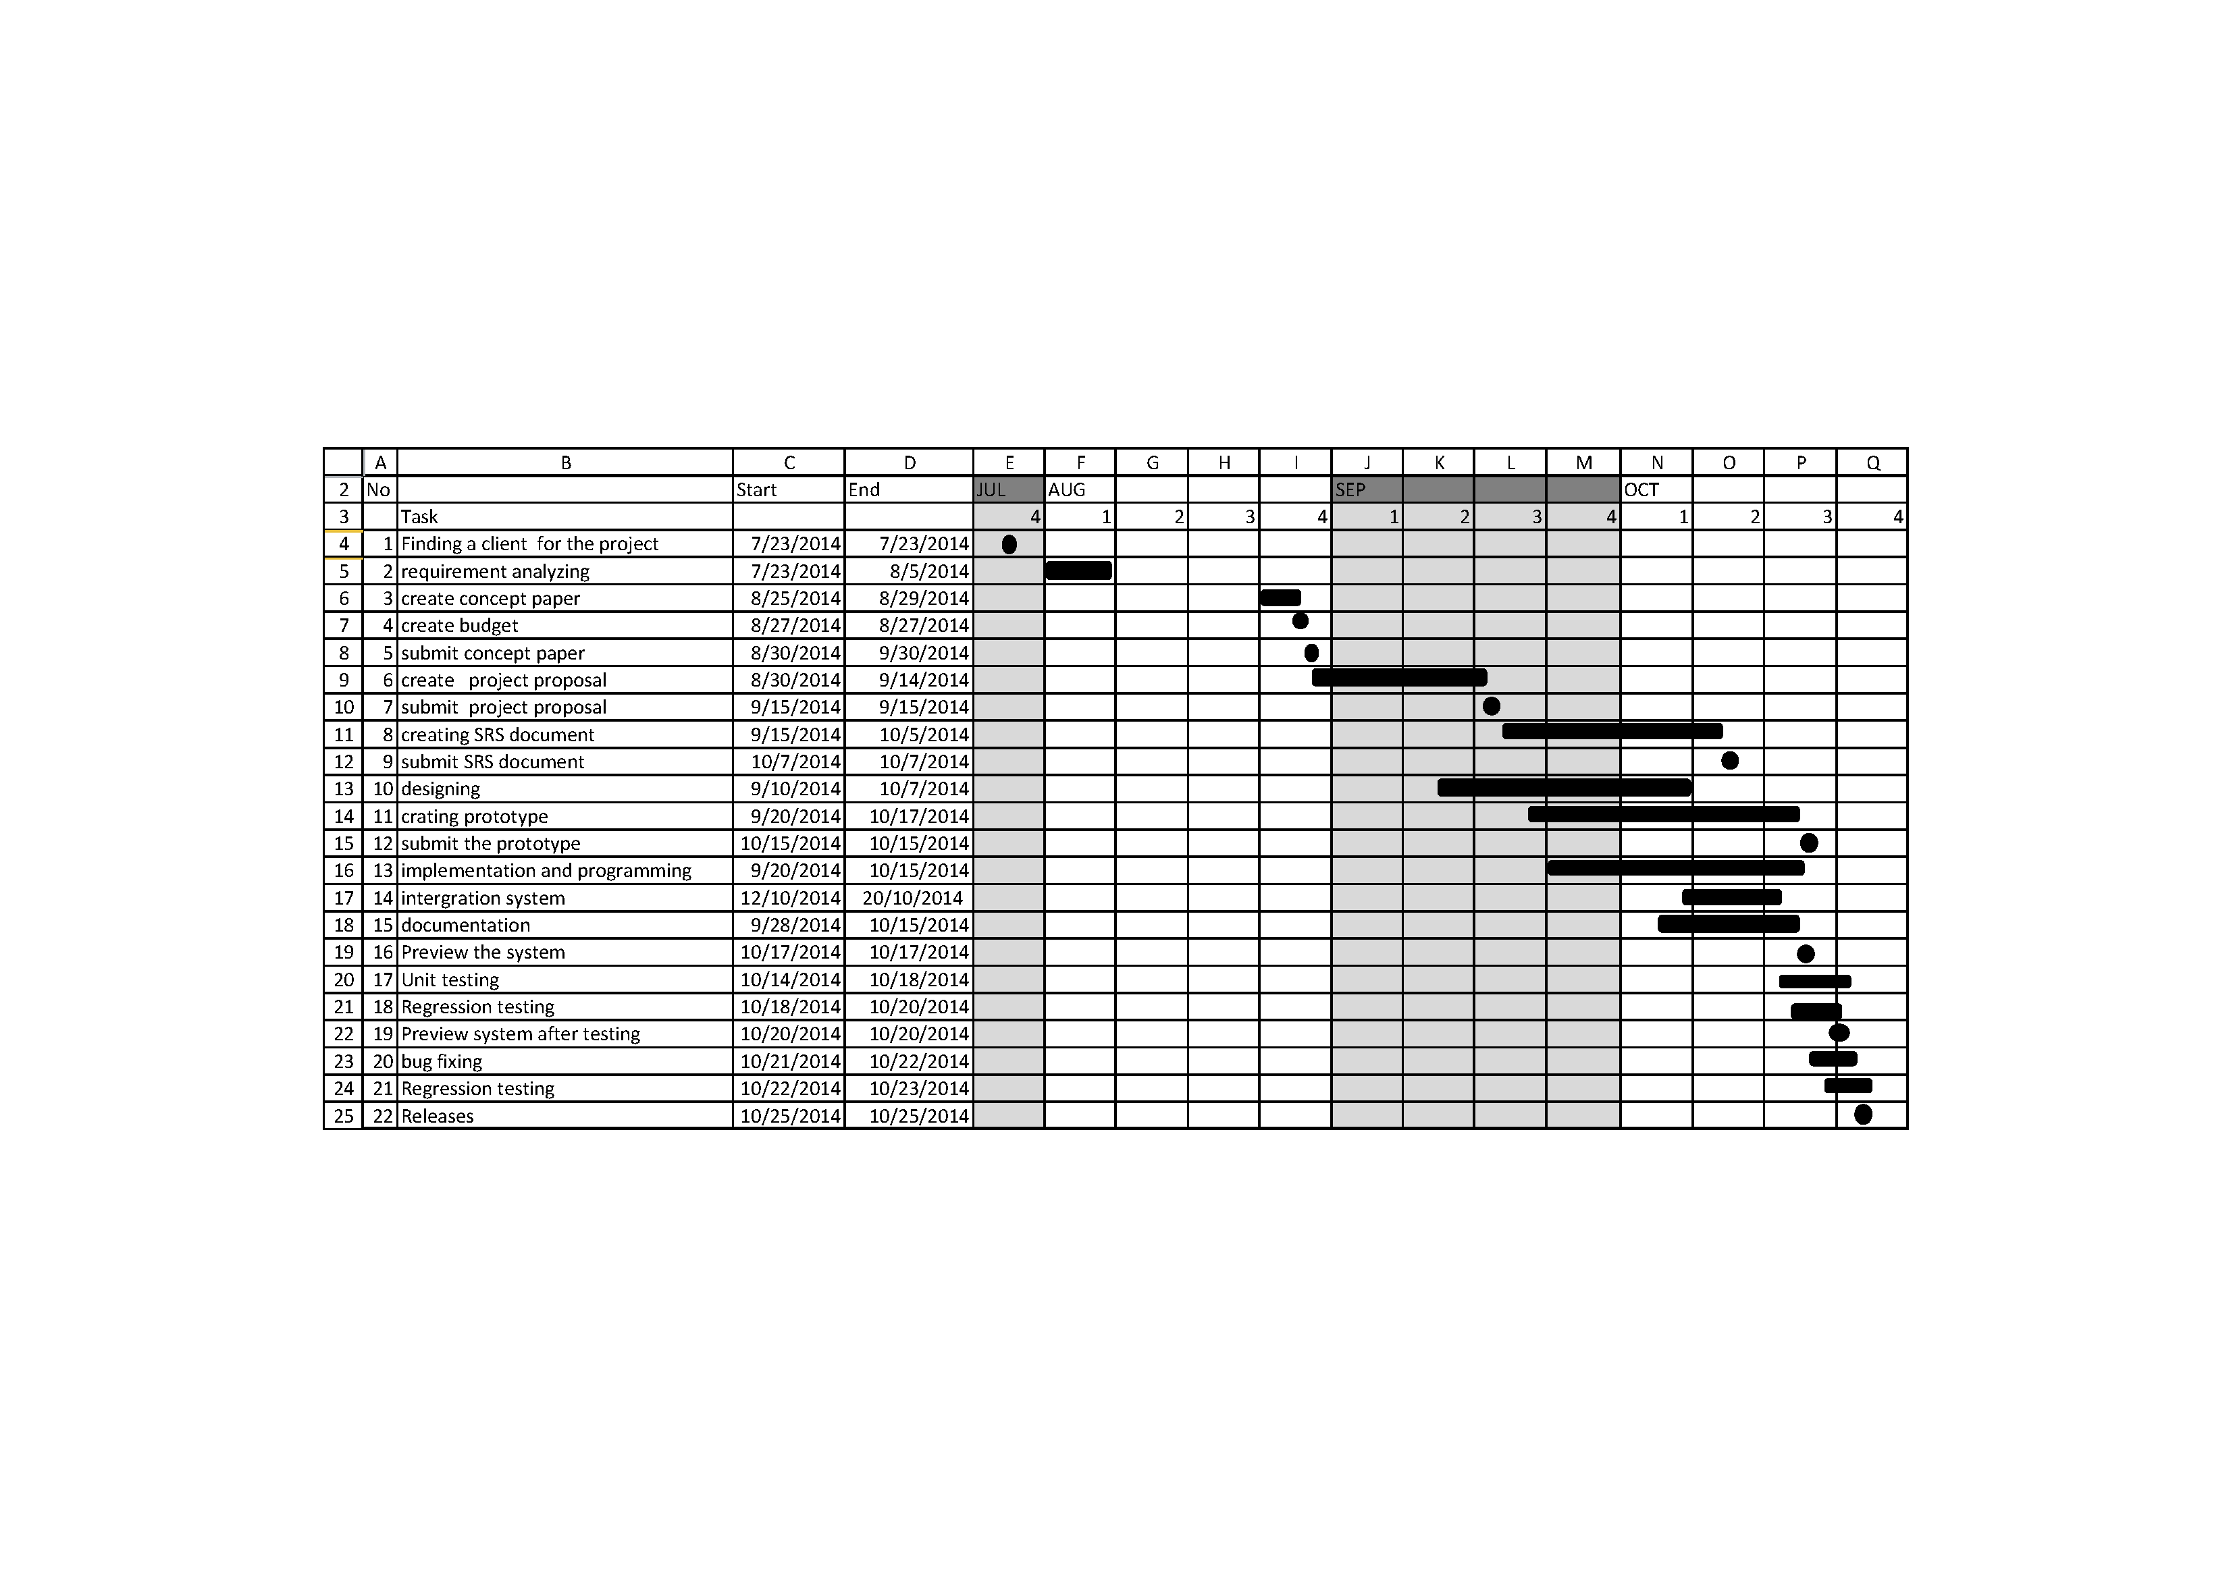

Figure 3.2: Gantt chart

**4. Personnel and Facilities**

|  |  |  |
| --- | --- | --- |
| **Student number** | **Members and roles** | **Function** |
| 13NU1217 | (SW team leader /programmer /tester/Group leader ) | **Developer**  (criteria checking system)  Database Design  Designing GUI  Coding  Documentation of the project Designing the system |
| 13NU1213 | (project manager/programmer/tester) | **Developer**  (interview data handling system)  Database Design  Designing GUI  Coding  Documentation of the project Designing the system |
| 13NU1177 | (coordinator/ programmer/tester) | **Developer**  (login system-user management)  Database Design  Designing GUI  Coding  Documentation of the project Designing the system |
| 13NU1211 | (Error handling / programmer/ tester) | **Developer**  (candidate’s system)  Database Design  Designing GUI  Coding  Documentation of the project Designing the system |
| 13NU1207 | (Documentation handling /programmer) | **Developer**  (data changing system)  Database Design  Designing GUI  Coding  Documentation of the project Designing the system |

Figure: 4. Personnel and Facilities

**5. Hardware and Software Requirements**

**5.1 Hardware Requirements**

To implement this recrutment System does not need a very high end machine. Because this system run in a web server and the user only sees the server generated HTML code which he views through a standard web browser. However broadband internet connection is suggested to gain a good performance.

**5.2 Basic System Requirement**s

1. 2.0 GHz processor with 2MB L2 cache Memory 512MB DDR II RAM Memory
2. 100 GB HDD (if necessary must expand as system request) (Other features in a pc won’t be a much issue)
3. Web server
4. System needs a web server which enables PHP, SQL, DNS server, Mail server, Security and an enough space to implement this recrutment system.

**5.3 Software Requirements**

* To run the HRM Automation System success fully in a operating system it need(Linux, Windows, Mac OS) and any kind of Browsers
* Adobe Dreamweaver CS6
* Adobe Photoshop CC
* MySql version 5.6.20
* Xampp 1.8.3-3-VC11- sever

**6. Budget**

The main expenses in this project are

• Travelling Charges

• Communication charges

• Document Preparing

• For Stationeries

And approximately these will take around Rs.5000.00 to cover up our expenses.

|  |  |
| --- | --- |
| **Description** | **Withdraw (Rs.)** |
| Travelling Charges | 1000.00 |
| Stationeries | 500.00 |
| Communication Charges | 500.00 |
| Document Preparing | 2000.00 |
| **Total** | **4000.00** |

Figure: 6.Budget

**7. References**

[1] PHP manual

www.php.net/docs.php

[2] PHP tutorials from following site.

www.w3schools.net

www.php.net

[3] General Manager of Inova IT Systems (Pvt) Ltd

[4] Library books & E-books